

K4 CSF3123 WEB-BASED INTERFACE DESIGN
SEM 3
LAB REPORT 7

PREPARED FOR:

ASSOC. PROF. TS. DR. WAN NURAL JAWAHIR
LAB ASSISTANT:
MISS WAN FATIN FATIHAH

PREPARED BY:
WAN NUR SYAFIQAH IZANI BINTI WAN HIZHAN
NO. MATRIC: S75776
SUBMIT BY: /12/2025

1.1
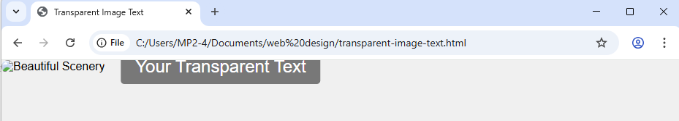
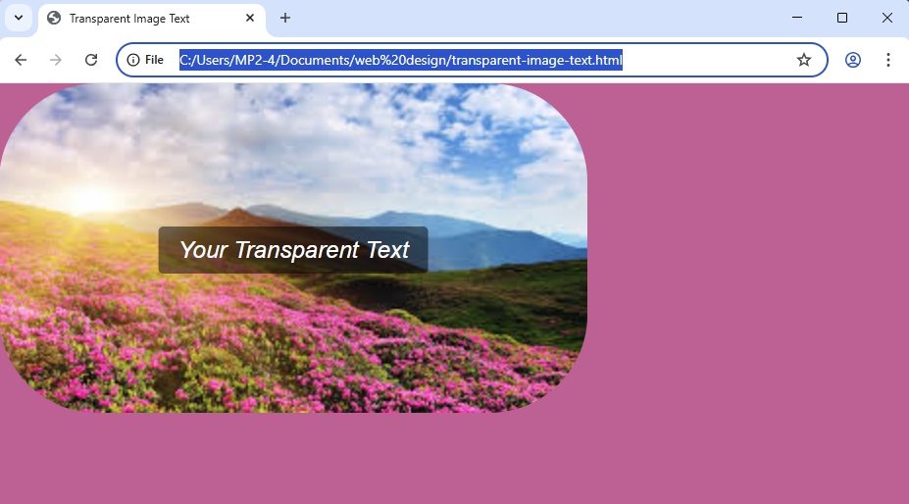
1.2
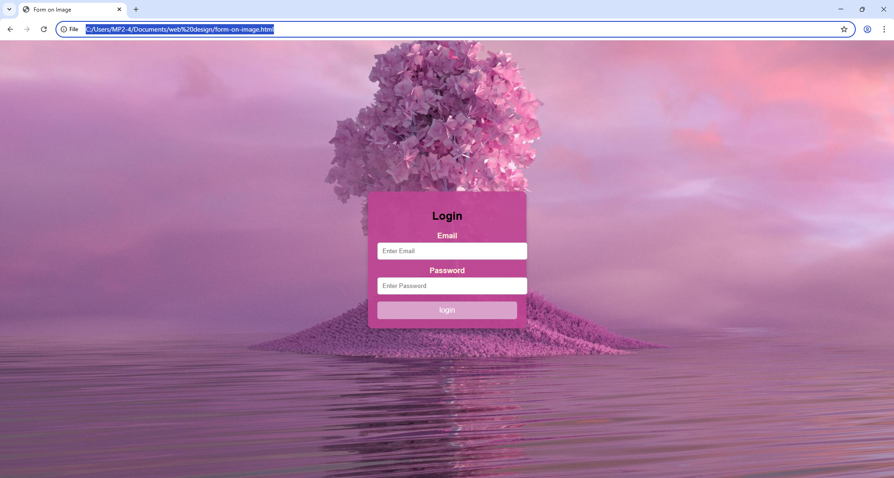

1.3
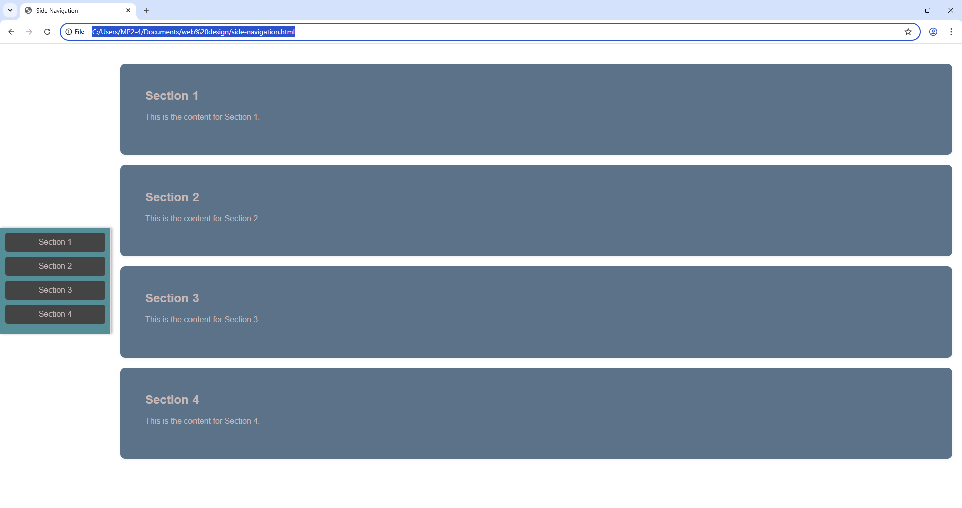
1.4
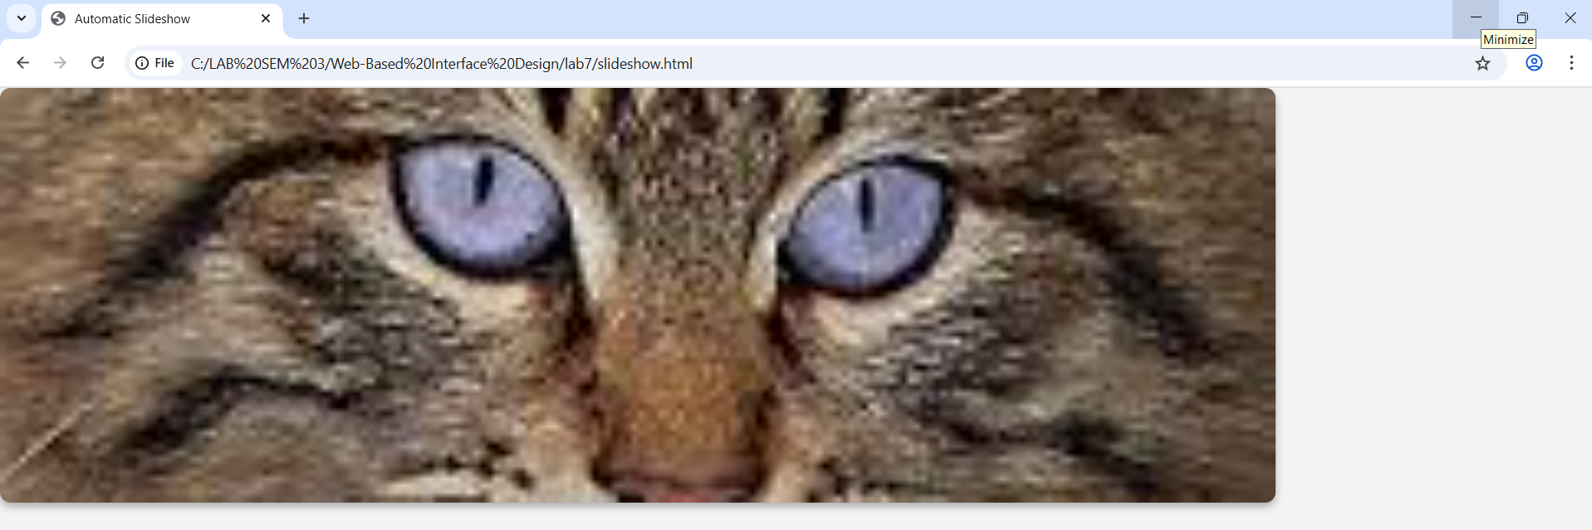
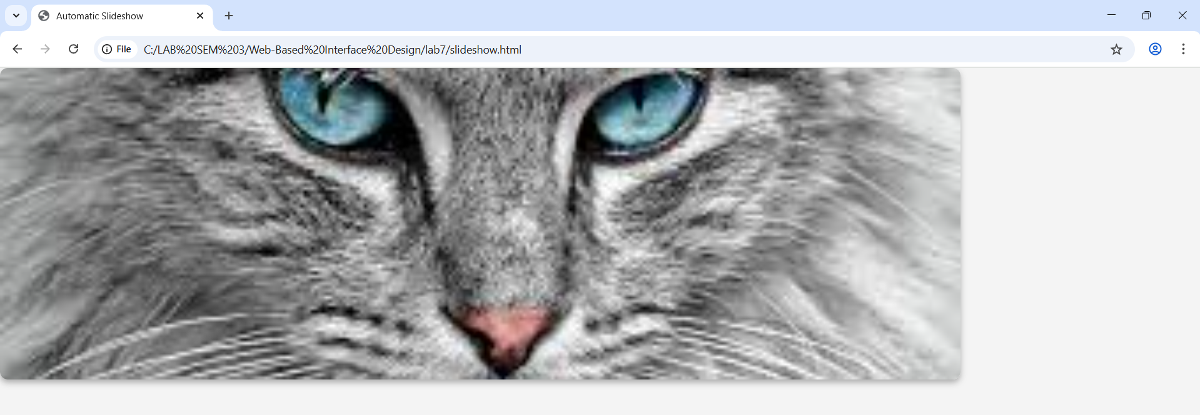
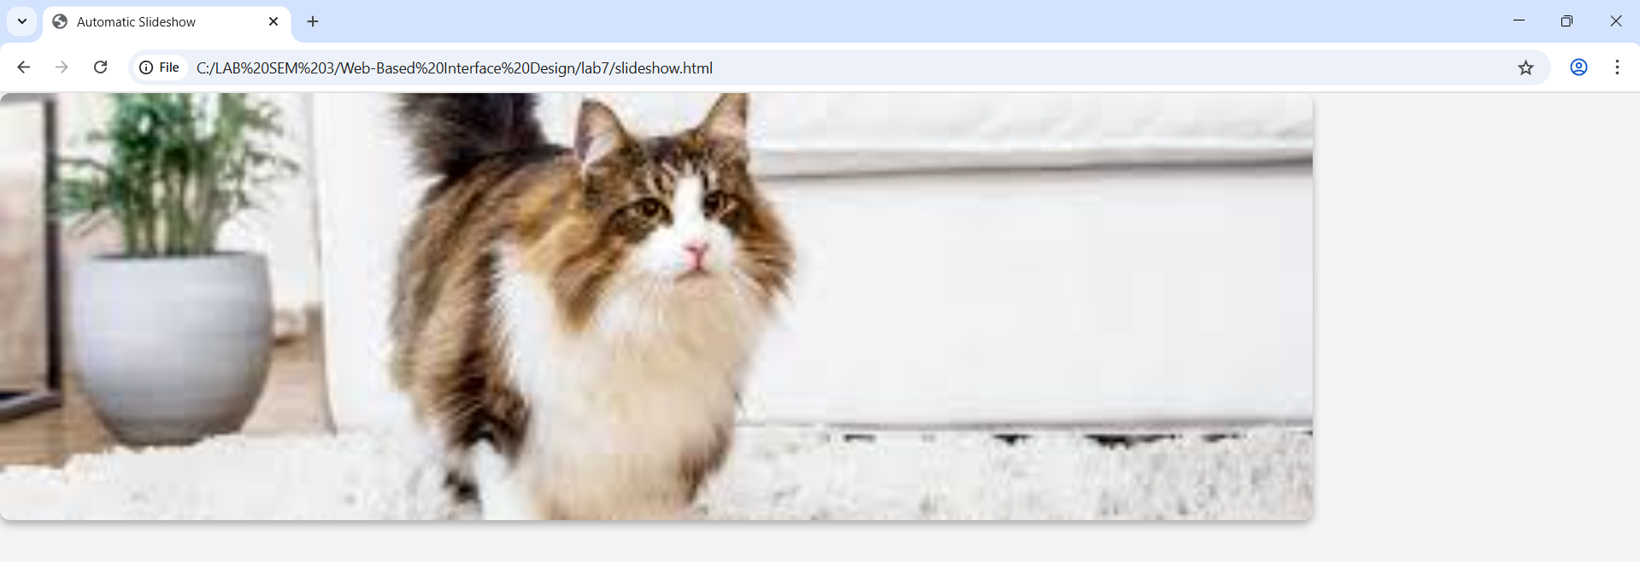
1.5

